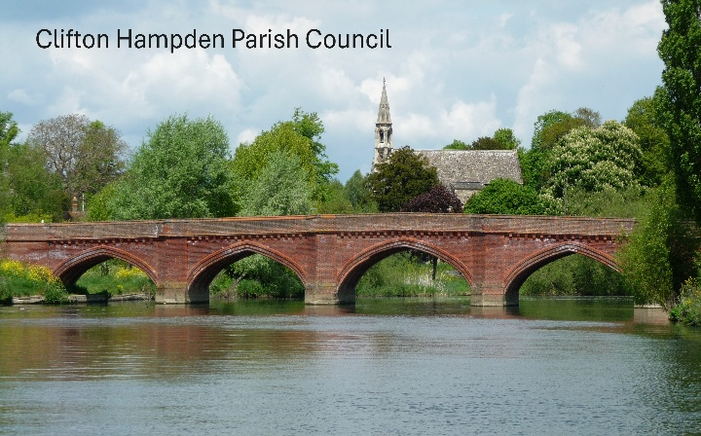

MINUTES OF THE ORDINARY MEETING OF CLIFTON HAMPTON PARISH COUNCIL
HELD ON MONDAY, 15th June 2026 AT 7:30PM IN THE CLIFTON HAMPDEN VILLAGE HALL

In accordance with the Local Government Act 1972 & Section 106 of the Finance Act 1992 Members are reminded that it is their responsibility to declare any interest in items that are to be discussed at the meeting.

Photographing, reporting, recording, filming, or transmitting the proceedings of a meeting may occur and therefore all persons participating in the meeting should be aware that such recording, reporting, or filming may take place. Members of the public attending the meeting (but are not participating in the meeting) who do not wish to be filmed or photographed in the meeting must state this at the start of the meeting. If members of the public do not wish to be filmed or recorded, they must sit in a designated area away from the recording equipment.

Clifton Hampden PC Cllrs Present:
Councillors: Chair: Kate Lowe (KL), Vice-Chair: Franck Doreau (FD), Svea Cheeseman (SC), Alex Seal (AS), Paul Sanders (PS), and Cllr Jo McManus (JM).

2 Members of the Public

MEETING MINUTES

1/171 To receive apologies for absence.
There were no apologies for absence.

2/172 To receive any declarations of pecuniary interest and/or requests for dispensations from Members regarding any item on this agenda.
There were no Declarations of Interest on any items on the agenda.

3/173 Public Participation. Members of the public may raise questions about and comment on items on the agenda. This session is limited to 15 minutes (3 minutes per person).
A Clifton Hampden Parishioner said that they had concerns regarding Buses/coaches going over the Bridge and that they may be over the weight limit. There is no signage currently which might need to be investigated. They also raised a concern about the Parish Council liaising with Thames Water about infrastructure works which would be happening at the same time.

A Burcot resident raised concerns about the quality of the wooden gates. Cllr Sanders mentioned that there is a plan to carry out some work to the gates when attaching the Speedwatch signs. Cllr Seal agreed to speak to Thames Valley Police regarding the results of a recent Speedwatch survey and report back to the Parish Council.

A Burcot resident also raised the idea of using Martin Drew to carry out some of the biodiversity work.
Cllr McManus said that she is putting together a strategy for the Wharf which includes a voice for all the stakeholders (Scouts, Parishioners, Conservationists, and Recreational users). This would also honour the intention of the Gibbs Estate when they bequeathed the Wharf to the Parishes. Cllr Cheeseman mentioned that the next maintenance requirements are due on the Wharf is in September.

4/174 Finance
- To receive the Finance Report
The Council acknowledged receipt of the above Report and as of 31 May 2026, the Clifton Hampden Parish Council Account stood at:

Unity Trust Current Account | £39,382.38

- Bank Statement –
to acknowledge scrutiny and acceptance of the previously circulated bank statement
The Council acknowledged receipt of the bank statement and confirmed that it had been reviewed and accepted.

- Banking – to consider the bank mandate and confirm signatories.
The Council RESOLVED to remove Cllr Paul Sanders and the Locum Clerk Gill Peacock from the existing Bank Mandate. The Council also RESOLVED to add Cllr Kate Lowe to the Mandate.

- Statement of Accounts – to consider and approve the Statement of Accounts for the year
ending 31 March 2026.
The Council RESOLVED to confirm the Statement of Accounts.

- Assets List –
to confirm the assets list for the year 2025/26 and set an appropriate minimum value of assets for the asset register.
There was a discussion regarding the valuation for the Village Hall and the potential for this to be updated. There was also some discussion regarding Clifton Hampden PC’s obligations as a Custodian Trustee for the Village Hall. The Council agreed to review the Trust Deed in order to understand the responsibilities that the PC has with regard to safeguarding the building.

The Council RESOLVED to confirm the assets list for the year 2025/26, in principle, however. They added a caveat that the Assets List would be reviewed by the Finance Working Group, including the provision of a solicitor.

- Internal Audit – to review the effectiveness of the Internal Audit
The Council acknowledged receipt of the Internal Audit and RESOLVED to agree that the Internal Audit Report had been effective.

- To receive and review the report from the Internal Auditor
The Council RESOLVED that following a review of the Internal Audit Report, they felt that there were areas of improvement that could be made in managing the Council’s finances. The Council confirmed that they did not currently receive a quarterly finance report and budget monitoring statement which should be accessible to the public. The Council confirmed that they had addressed the most pressing concerns, however, the Report had highlighted a number of issues which the Council would take into consideration in order that in future the Council would be more compliant.

- To consider the appointment of the Internal Auditor for 2026/7
The Council RESOLVED to agree the appointment of Deborah O’Brien, as the Council’s Internal Auditor for a further year.

- AGAR Signature Redaction – to consider redaction of the signatures on the web
version of the Annual Governance and Accountability Return to protect the signatories from ‘specific and identifiable threats of identity theft and GDPR concerns.
The Council RESOLVED to agree to redact the signatures on the web version of the AGAR acknowledging that this was against the Accounts and Audit Regulations, but that it was to protect the signatories from the specific and identifiable threats of identity theft. There was no issue with the full documents being viewed in person.

- External Audit – to consider the 2025/26 AGAR for submission to the External Auditor

- Section 1 – Annual Governance Statement
All Councillors to consider the questions and respond accordingly. To approve and sign Section 1.
The Chair read out all the questions in Section 1 of the Annual Governance Statement for consideration. The Council RESOLVED to agree to all the Governance questions and ticked the appropriate boxes accordingly. The Chair signed the form as required; on the advice of the internal auditor.

- Section 2 – Accounting Statement
To consider and agree the accounting statement figures. To approve and sign Section 2
The Locum Clerk had provided the Councillors at the meeting with the appropriate figures, and the Council RESOLVED to agree the Accounting Statements. The Locum Clerk had signed the form prior to the meeting, and the Chair also signed the form, together with Cllr Seal to verify the process which had been completed. Cllr Sanders advised that VAT reclaims should be considered when preparing the Council’s annual budget.

- Electors’ Rights – to note the dates for the Notice of Public Rights
The Council RESOLVED to approve the dates for the Electors’ Rights as Wednesday, 17th June to Tuesday, 28th July 2026. The notice would be posted in accordance with the Regulations.

- Statement of Variances – to consider the draft Statement of Variances.
The Council discussed how CIL monies are allocated and how the timing of the payments can be arranged. The Council RESOLVED to agree the Statement of Variance for the fiscal year 2025/26.

The Council agreed that the Annual Governance and Accountability Statement and all of the supporting documents would be published on the Clifton Hampden PC website.

b. Invoices for Payment - to consider and approve invoices for payment itemised on the Payment Schedule below
The Council RESOLVED to approve the invoices noted below:

Deborah O’Brien – Internal Audit and Report | £200.00
sld-ltd.- Printing 2 A2 Plastic dog signs for Recreation Ground | £154.00
Olly Bowden – Gardening work | £60.00
Clerk Salary for June | £400.03
Simplicity Payroll - May Payroll | £26.40
Gill Peacock, Locum Clerk for administration of the Parish Council plus Expenses | £600.00 plus 2 X Printer Cartridges - £22.84 + £22.71 = £45.55

5/175 To consider the installation of Speed Watch signs to be placed in all four corners of the Villages, in accordance with a quote received (circulated previously).
Following a discussion, the Council RESOLVED to purchase the Speed Watch signs with a
local Sign Company at a total cost of £365.09 (incl. VAT).

6/175 To pass a resolution in accordance with the Public Bodies (Admission to Meetings) Act 1960, Part 1, Section 1 (2) to exclude the public and press for discussion, where publicity might be prejudicial to the special nature of the business.
Cllr Lowe proposed passing a resolution to exclude the public and press due to Clifton Hampden PC Cllrs wishing to discuss a staffing related matter in private session. Cllrs unanimously RESOLVED to approve this motion.

Date of Next Meeting:

Monday, 20th July 2026 – Ordinary Parish Council Meeting

Signed ……………………………………………….

Dated …………………………………………………

