Oxfordshire County Council Parish Report
August/September 2026

Councillor Robin Jones
(Green Party)
(Berinsfield & Garsington Division)
(Berinsfield, Burcot, Clifton Hampden, Culham, Drayton St. Leonard, Garsington, Nuneham Courtenay, Sandford-on-Thames, The Baldons)
Email: Robin.Jones@Oxfordshire.gov.uk
Mob: +44 7916 293681

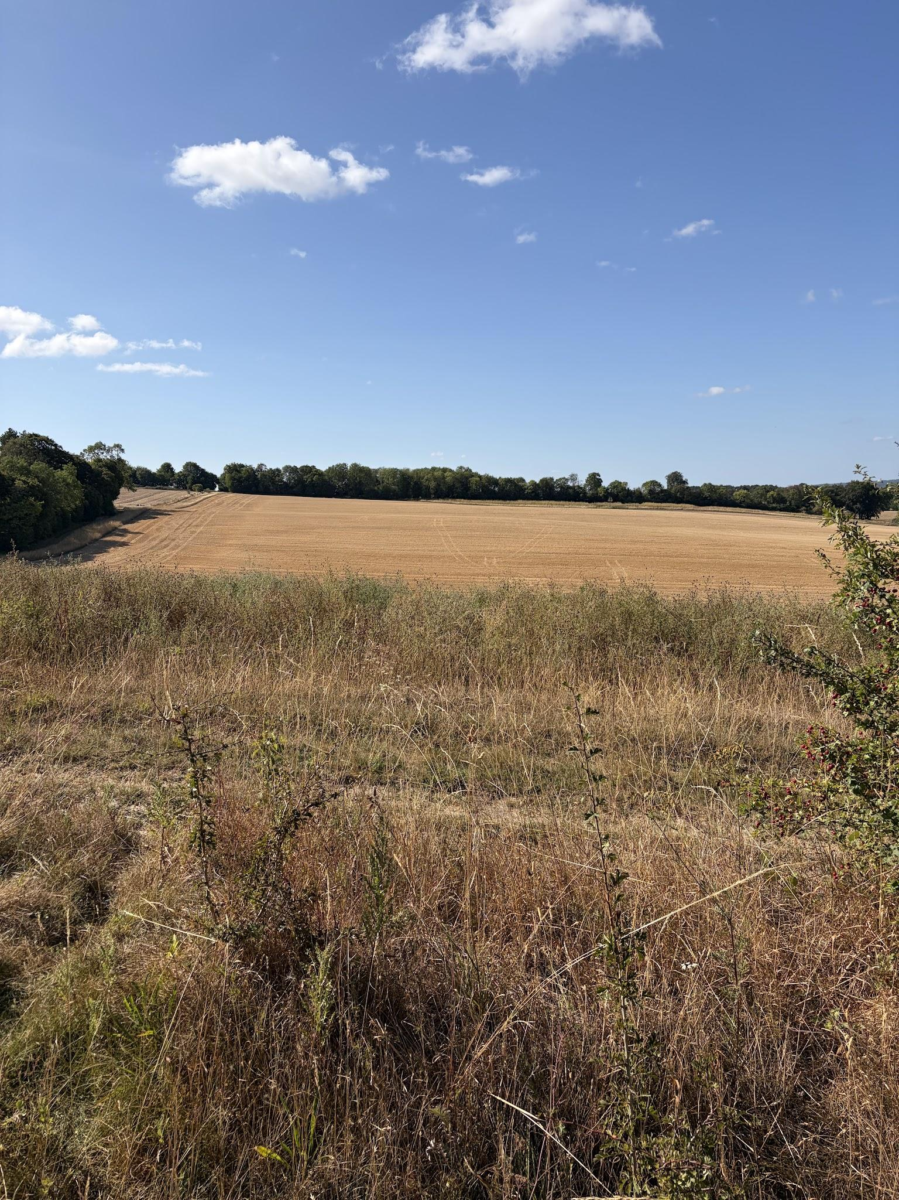

Local Government Reorganisation PAUSED
Hot on the heels of the 16th July parliament announcement that Oxfordshire and West Berkshire’s seven existing councils will be replaced by three unitary councils from 1 April 2028 as part of its plans for local government reorganisation (LGR), Angela Rayner said on Monday 7th September that the process will now be put on pause as she seeks legal advice around procedure. The govt is still minded to proceed with LGR but there is currently no indication as to timeline. Elections that are normally expected will continue according to current boundaries. For now!

Oxford congestion charge

From 28th Sept 2026, six new traffic filters will replace Oxford's temporary congestion charge. This will follow the planned reopening of Botley Road on 20 September. Any Oxfordshire resident can apply for a permit allowing up to 25 free day passes through the new traffic filters. If you already have a congestion charge permit it will automatically transfer to the traffic filters. Additional permits are available for many groups, including Blue Badge holders, unpaid carers, community health and care workers, mobile traders and patients who need frequent hospital appointments in the Oxford area. Congestion charge exemptions and permits | Oxfordshire County Council

Public Footpath Map and Reporting

There is a new website to report problems on public footpaths in Oxfordshire instead of FixMyStreet. You will need to login / create an account before you can see the options to report a footpath for repair. Public Rights of Way - Report a Problem

Green Motion at Council Passed Unanimously
OCC Green Councillors brought a motion on Housing development road and infrastructure adoption to the Full County Council meeting on Tues 8th Sept which received cross-party support and was carried unanimously. It recommended stricter requirements for timelines for road, drainage, pavement and verge adoption to prevent residents being left without recourse with deteriorating roads.

Tree Planting

New tree planting due for Autumn 2026, maps of potential sites can be found here: TreePlotter - Oxfordshire County Council

